A TECHNICAL REPORT ON STUDENT’S INDUSTRIAL WORKS EXPERIENCE SCHEME (SIWES)

AT

PHYSICAL PLANNING, FEDERAL POLYTECHNIC,
MUBI, ADAMAWA STATE

BY
MOHAMMED SHARIF MOHAMMED
ET/CE/ND/24/006

DEPARTMENT OF CIVIL ENGINEERING TECHNOLOGY, FEDERAL POLYTECHNIC, MUBI.

FEBRUARY, 2026

A TECHNICAL REPORT ON STUDENT’S INDUSTRIAL WORKS EXPERIENCE SCHEME (SIWES)

AT

PHYSICAL PLANNING, FEDERAL POLYTECHNIC,
MUBI, ADAMAWA STATE

FROM: 25TH AUGUST, 2025
TO: 13TH DECEMBER, 2025

TITLE PAGE

BY
MOHAMMED SHARIF MOHAMMED
ET/CE/ND/24/006

THIS TECHNICAL REPORT IS SUBMITTED TO THE DEPARTMENT OF CIVIL ENGINEERING TECHNOLOGY, IN PARTIAL FULFILLMENT OF THE REQUIREMENT FOR THE AWARD OF NATIONAL DIPLOMA (ND) IN CIVIL ENGINEERING TECHNOLOGY, FEDERAL POLYTECHNIC, MUBI.

FEBRUARY, 2026

DEDICATION
This technical report on students Industrial Work Experience scheme (SIWES) is dedicated to God Almighty, my parents and to my beloved brothers and sisters.

ACKNOWLEDGEMENT
I wish to acknowledge God Almighty for his infinite goodness, mercy and protection over my life through this training and professional program at large.
In official way I wish to acknowledge my beloved parents for her loving and wonderful support over the phase of the event and my beloved brothers and sisters and all my family members and friends who work hard in contact to support and ensure that he program is rated successfully and I pray that may God in his infinite mercy, guide, bless, enrich, protect and support them in the ways of their life and health status, likewise financially encounter them with supernatural breakthrough in all phase of life.
I also wish to acknowledge my SIWES supervisor Engr. Umar Farouk Adamu and SIWES Coordinator in person of Mahmud Mudunde for their effort ensuring the success of the industrial training programme.
I faithfully, acknowledge my Honourable Head of Department in person Engr. Sunu Jude and all the staff of Civil Engineering department together with my fellow course mates for their support to enhance this training a successful one. I pray that may God continue to bless and support them financially, academically throughout their life time. Amen.

ABSTRACT
This technical report presents a detailed account of the knowledge and practical experience acquired during my four (4) months Student’s Industrial Work Experience Scheme (SIWES) at the Physical Planning Directorate, Federal Polytechnic, Mubi, Adamawa State, from 25th August, 2025 to 13th December, 2025. The training exposed me to real-life civil engineering practices and site operations, enabling me to bridge the gap between classroom theory and practical application. During the training period, I participated in various construction activities such as site clearance, setting out using the builder’s square method, excavation of foundation trenches, concrete mixing, concrete base formation (blinding), block work, lintel construction, and drainage construction. I was also exposed to reinforcement detailing, sub-grade preparation, and the use of hand tools and construction equipment. These activities enhanced my understanding of construction procedures, safety measures, teamwork, and professional ethics in engineering practice. The SIWES programme has greatly improved my technical skills, confidence, and problem-solving ability in civil engineering works. It has also provided me with valuable industrial exposure that will contribute positively to my academic and professional development.

TABLE OF CONTENTS
TITLE PAGE i
DEDICATION ii
ACKNOWLEDGEMENT iii
ABSTRACT iv
TABLE OF CONTENTS v
CHAPTER ONE 1
1.0 INTRODUCTION 1
1.1 MEANING OF ITF 1
1.2 AIM OF ITF 1
1.3 OBJECTIVES OF ITF 2
1.4 MEANING OF SIWES 2
1.5 AIM OF SIWES 2
1.6 OBJECTIVES OF SIWES 3
1.7 SIGNIFICANCE OF SIWES 3
1.8 HISTORY OF THE ORGANIZATION 3
1.9 COMPANY ORGANOGRAM 1
CHAPTER TWO 1
2.1 INTRODUCTION TO SITE 1
2.1 SITE CLEARANCE 1
2.2 SETTING OUT 1
2.3 EXCAVATION OF FOUNDATION 2
CHAPTER THREE 5
3.1 CONCRETE MIXTURE 5
3.1.2 CONCRETE BASE FORMATION (BLINDING) 5
3.2 BLOCK WORK 7
3.3 LINTEL CONSTRUCTION 9

CHAPTER FOUR 11
4.1 DRAINAGE CONSTRUCTION 11
4.2 DRAINAGE SYSTEM MAINTENANCE 13
4.3 SOME HAND TOOLS USED 14
CHAPTER FIVE 17
5.1 CONCLUSION 17
5.2 RECOMMENDATIONS 18
REFERENCES 19

CHAPTER ONE
- INTRODUCTION
The Student’s Industrial Work Experience Scheme (SIWES) is a skill training programme designed to expose and prepare students in institution of higher learning.
This skill is also meant to expose students to working manner of some organization in the country and give them the required experience and practical to know how to handle equipment and machinery that may not be found in their institution.
The SIWES programme is finance by the Federal Government of Nigeria through the industrial training Fund (ITF) board. In most case, the capital used is partially obtained from taxing the registered companies and the federal government donated the remaining funds. The SIWES as a cooperation between industrial and institutional of higher learning in Nigeria is a continuation of student studies.
  - MEANING OF ITF
The industrial training fund was established by the decree No. 47 of 8th October 1971, with the aim of promoting and encouraging skills and acquisition of skills in industrial and commerce with a view of generate a pool of indigenous manpower to meet the need of the economy of the country.
  - AIM OF ITF
The aim of ITF is for promoting and encouraging the requisition of skills in industrial and commerce with a view to generate a pool of indigenous trained manpower and sufficient to meet the need of the economy.

  - OBJECTIVES OF ITF
- Building of training facilities of its own in identified area of national need.
- The establishment of uniform national vocation and apprenticeship training scheme in the country.
- Bearing a proportion of direct cost of the Job and off-job training Nigeria employees.
- Organizing research students as support to other activities of the fund.
- Seeking the harmonized ITF no formal training programme with the curricular formal education institution.
  - MEANING OF SIWES
The programme SIWES is the student industrial work Experience Scheme which is coordinated by the industrial training fund (ITF).
The scheme helps the students to be exposed to the practical knowledge that he might not get in school during his course of study.
  - AIM OF SIWES
- To help student to see practically what have been taught earlier in classroom.
- To reconcile theory work with that of practical.
- To enable students to practically take part in ensure greats production.
- To help student greatly to know the rule and regulation and procedure of the work.

  - OBJECTIVES OF SIWES
- To expose student to equipment practically.
- To provide knowledgeable and efficient graduates under each related fields
- To increase the number of skilled worker
- To bring cooperation between the employer and the estuation so as to work hand enhanced and to know what type of student to be produced and to what extent.
- To enable the students practice their profession even after school, not only at working level even personally.
  - SIGNIFICANCE OF SIWES
- It help student to gain job experience in life
- It provides an opportunity to student to pulling human relation forest by exposing students to actual working environment.
- It help student to be skilled and knowledgeable in handling industrial equipment and tool.
- It help students to apply principle taught in school successful on job assign to him/her.

1.8 HISTORY OF THE ORGANIZATION
The Physical Planning Directorate, Federal Polytechnic, Mubi, Adamawa State, was established in the year 2009, with the sole aim of planning, design, construction and supervision of new project in the Federal Polytechnic, Mubi be it in contract or direct labour. And procurement and preparation of land document.
The following are some units in the Physical Planning Directorate, Federal Polytechnic, Mubi;
Architecture: Responsible for design and supervision of construction works in the Polytechnic.
Civil Engineering: Responsible for the supervision of construction of structural element during construction.
Building Tech: Responsible for supervision and quality control.
Town planning: Planning and maintaining the layout plan of the polytechnic.
Quantity surveyor: Participates in tendering, preparation of contract document, valuation etc.
Craft men: Assist the professional in carrying out their duties
Admin: The Administrative staff supports all the staff in the directorate.

1.9 COMPANY ORGANOGRAM
DIRECTOR OF WORKS
TOWN PLANNERS
PRINCIPAL TOWN PLANNERS
ARCHITECTS
ADMIN
ENGINEERS
ASST. CHIEF TECH OFFICER
CHIEF ARCHITECT
BUILDING ENGINEER
CIVIL ENGINEER
PRINCIPAL BUILDING ENGR..
ASST. CHIEF TECH OFFICER

FOREMAN
FINANCIAL TECHNICIAN
PRINCIPAL TOWN PLANNERS
ASST. CHIEF TECH OFFICER

PRINCIPAL EXECUTIVE OFFICER
HIGHER EXECUTIVE OFFICER

CONFIDENTIAL SECRETARY
CLERK
LAB ATTENDANT

Figure 1.1: Organogram

CHAPTER TWO

2.1 INTRODUCTION TO SITE
A site is a place of construction where the work is undertaken, it is usually associated with engineering work.

2.1 SITE CLEARANCE
Before the excavation of the proposed foundation commences, we cleared the site. So therefore, site clearance is the removal of all accumulated waste from an area to ensure that it is free from any environmental hazard, obstacle or unsightly mess.

2.2 SETTING OUT
Square method was used for the setting out, as observed after 90 from all angles using the pages ropes string and also from the plan. Setting out is done with high degree of accuracy or else the building will not last as the engineer answered to my question “why are some calculations made during setting out”.
The method of the setting out used at the site is the builder’s square method
Procedure for the builder’s square method of the setting out:
- After site clearance material to be used were made available at the site.
- Proper site measurement was taken and all angles of the site were noted.
- Lines and blocks to be used were made available.
- Builder’s square was used to align the blocks and a line was used to extend the alignment to another angle of the site as specified in the floor plan, this was done continuously.
- The same method was applied to obtain all the angles of the building, by using this procedure demarcation, foundation boundary was made which brings about the starting point of excavation.
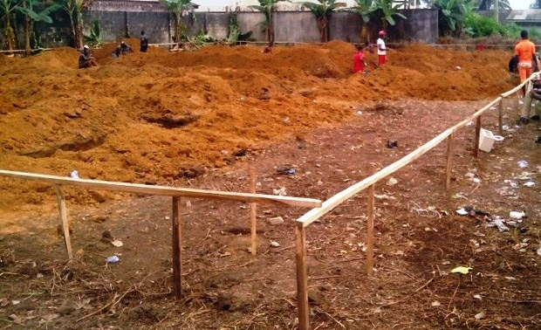
Plate 2.1: Setting out using
Source: Author’s work, 2025

2.3 EXCAVATION OF FOUNDATION
Excavation can be defined as the process of digging a soil surface or trench for foundation lay into trench.
It is also the process of removing top soil for foundation trenches. Excavation work is an important part of building operation that commences immediately after setting out the width of excavation for foundation trenches is marked out on the profile and then transferred to the ground. Excavation must be carried out carefully to ensure safety of workers.
Excavation can be done using two methods mechanical and manual. In small construction we normally use manual method while in large construction we use mechanical e.g. like road construction.
Excavation work were carried out manually where unskilled labourer where involved with digger, shovels, head pan and wheel barrow. The following factors must be considered when carrying out any excavation work.
- Nature of the soil
- The width and depth of foundation
- Climatic condition at the time of excavation
- The water table of the soil
- The period excavation work is expected to be left open.
- The effect of excavation on existing adjacent structure.
As the engineer and the former goes to set basket, I was keeping an eye on how the beams were set. When digging the basket some places were 1.2 while some other places were 1.4 by 1.4 because of the type of soil on the site. When putting the basket in a poor soil, cement and sharp sand is mixed out before putting the basket to avoid rusting.
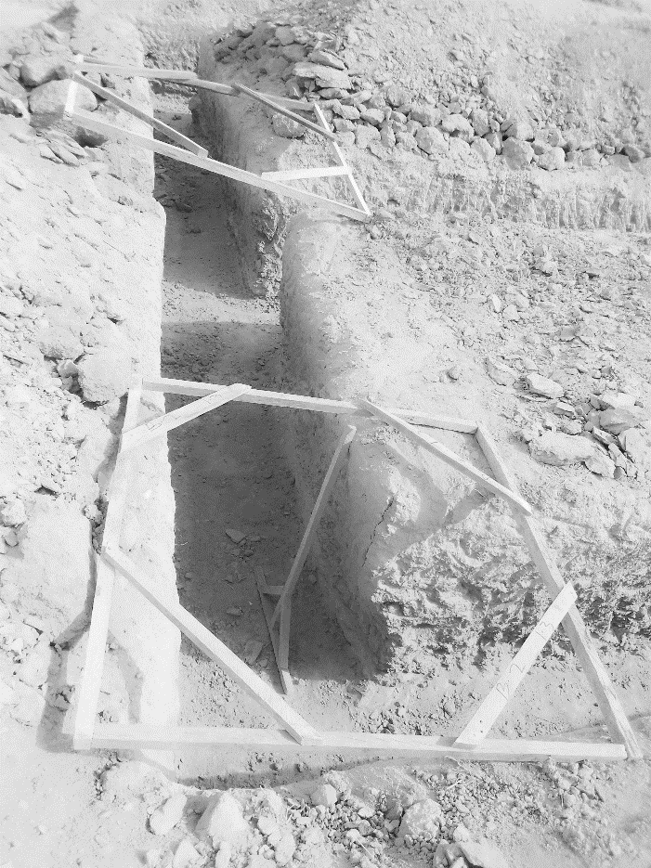
Plate 2.2: Excavation
Source: Author’s work, 2026
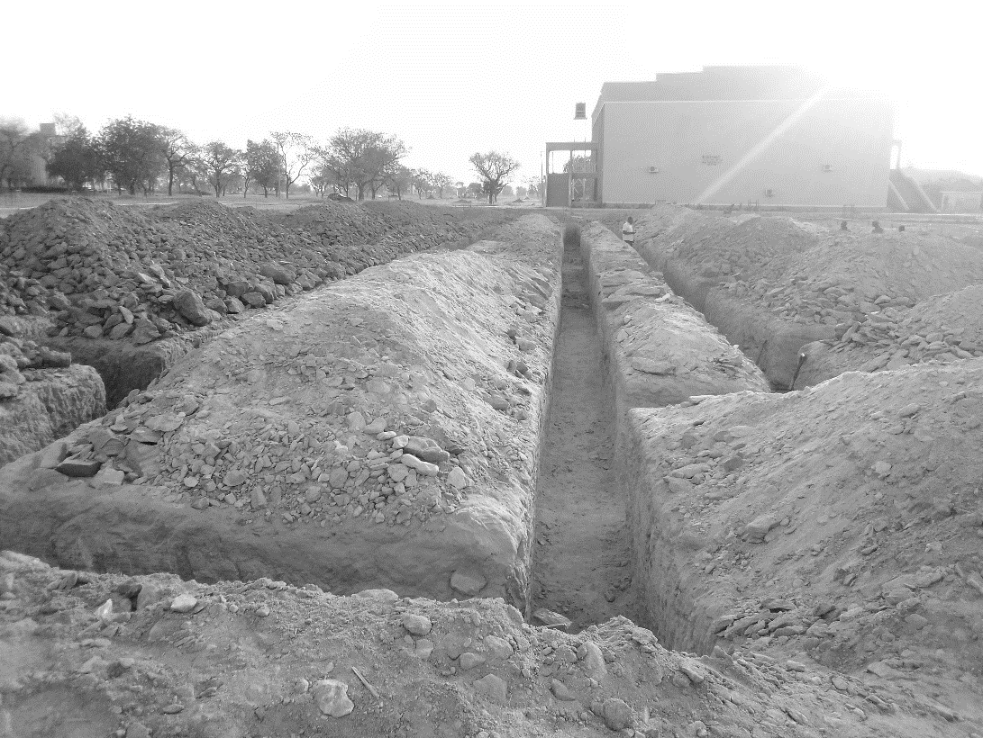

Plate 2.3: Excavation
Source: Author’s work, 2026

CHAPTER THREE

3.1 CONCRETE MIXTURE
Concrete is a mixture which comprises of sand, cement, coarse/fine aggregates, water and other required materials that may be used in certain cases such as drainage, culverts and bridges etc. The concrete can be mixed either manually or using machine.
The concrete used during the drainage construction was mixed on the using the cement mixer and to the ratio 1:2:2, which means 1 part cement to parts of sand to 2 parts of gravel but in some situations whereby the concrete mixer does not seem to be balanced materials such as sand or gravel can be added to balance the mix. The concrete was transferred to the site using wheel barrow and placed immediately in the trenches.

3.1.2 CONCRETE BASE FORMATION (BLINDING)
This is a layer of the excavation usually 15 to 20mm thick. Wet concrete is put down on the surface of the excavated ground so as to seal the surface and provide the trench for setting and forming the block and also in the base for the layer of the concrete to obtain hard based for the fixing of U-channel.
The purpose and function of blinding that was carried out during my SIWES program for the drainage construction are as follows:
- To avoid cracking in construction;
- Differential Settlement;
- Stability; and
- Durability.
These are the function and purpose of blinding during the construction of trenches and excavation of the soil as shown in the Figure 1 below.
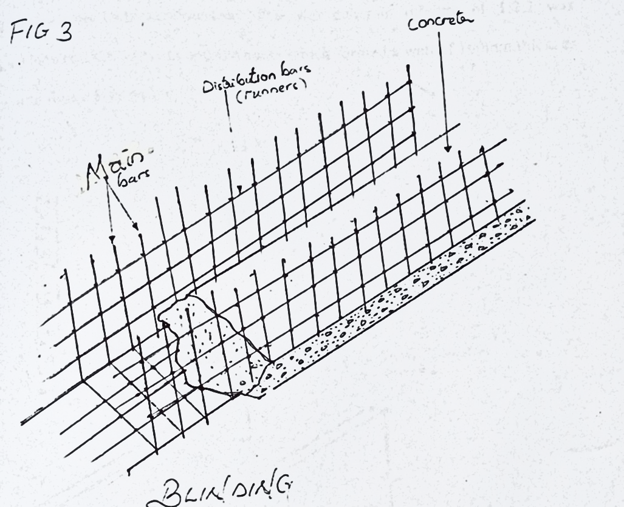
Figure 3.1: Concrete Base Formation (Blinding)
Sub-grade was compacted before the construction of a road or pavement and usually stabilized by the addition of asphalt, lime, Portland cement or other modifiers. The sub-grade is the foundation of the pavement structure on which the sub-base is laid. The load bearing strength of sub-grade is measured by California Bearing Ration (CBR) test and other methods.

3.2 BLOCK WORK
Blocks were molded in a number of sizes, various compositions, strengths, and shapes such as 9 inches and 6 inches. The 9-inch blocks were used for external walls, while the 6-inch ones were for internal walls. After the foundation work was finished, the blockwork was built to cover the spaces as well. All the blockwork did not carry any load; they were erected to cover spaces and also act as partition walls.
Procedure
- Before starting the block laying process, the site was prepared by clearing debris and ensuring a level foundation.
- The layout of the walls or structure was marked using chalk lines or strings to guide the placement of the blocks.
- Blocks or bricks were selected based on the desired strength, size, and aesthetic requirements of the project.
- Mortar was mixed according to the specifications, typically using a combination of cement, sand, and water.
- A layer of mortar was spread evenly along the foundation where the first course of blocks would be placed.
- A level was used to check the horizontal and vertical alignment of the blocks.
- Once the first course was laid, additional courses of blocks were added on top, following the same process.
- Each block was buttered with mortar on its ends before being placed to ensure a strong bond between the blocks.
- Blocks may have needed to be cut to fit around corners, openings for doors or windows, or to maintain the desired pattern.
- Excess mortar was scraped off the joints using a trowel, and any gaps or voids were filled to create a smooth, uniform surface.
- Once the block laying was complete, the work area was cleaned up, and any excess materials or debris were removed from the site.

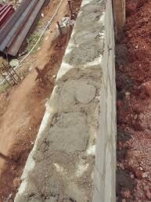
Figure 3.2: Block work
Source: Author’s work, 2026.

3.3 LINTEL CONSTRUCTION
After completing the blockwork up to the required height for doors and windows, we proceeded with the construction of lintels a critical phase in providing structural support above all openings. The process began with the marking and measurement of all door and window openings to determine the exact length of each lintel. Once the dimensions were confirmed, the carpenters constructed the formwork (shuttering) for the lintels using strong timber, ensuring it was firmly braced and properly aligned.
Next, we tied the reinforcement bars according to the structural drawings. These bars were essential for strengthening the lintel and distributing the load above the openings. Spacers were used to maintain cover between the reinforcement and the formwork, which helps protect the steel from corrosion. Once the reinforcement was fixed and inspected by the engineer, we proceeded to pour concrete into the lintel formwork. The concrete mix was properly proportioned and vibrated to remove air pockets and ensure proper bonding and compaction. The top of the lintel was leveled and finished neatly using a trowel. After pouring, the lintels were left to cure and gain strength, and we kept the surface moist regularly to aid the curing process. The formwork was not removed until the concrete had fully set and reached the required strength, usually after 7 to 14 days. This stage was particularly important as the lintels help in transferring the loads from above openings to the supporting walls on both sides. Being part of this process helped me understand the importance of accuracy, proper formwork, and reinforcement placement in lintel construction.
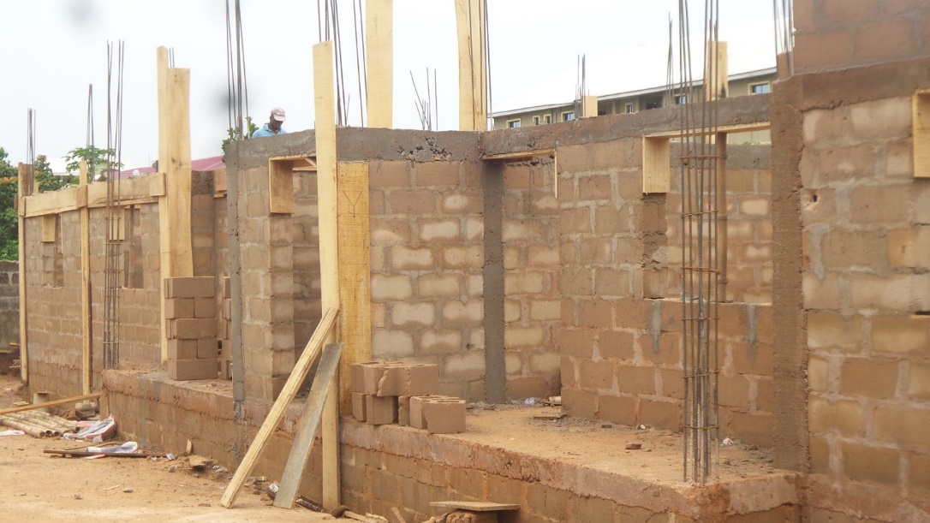
Plate 3.3: Casting of lintel
Source: Author’s work, 2026

CHAPTER FOUR

4.1 DRAINAGE CONSTRUCTION
Drainage reinforcement involves the process of strengthening drainage structures to ensure durability, stability, and resistance to erosion or structural failure. Reinforced drainage systems are crucial in managing water flow, preventing flooding, and maintaining the integrity of surrounding structures. The reinforcement process typically includes the use of steel bars, concrete, and other strengthening materials to enhance the load-bearing capacity of the drainage channels.
- Site Preparation – The drainage path was cleared of debris, vegetation, and loose soil to provide a stable foundation for construction.
- Excavation – The trench for the drainage system was excavated to the required depth and width, ensuring proper slope and alignment for efficient water flow.
- Formwork Installation – Wooden or steel formworks were set up along the trench to shape the reinforced concrete structure and maintain alignment during the pouring process.
- Steel Reinforcement Placement – Reinforcing bars (rebars) were cut, bent, and arranged according to the design specifications. The bars were tied together using binding wire to create a reinforcement framework within the drainage channel.
- Concrete Mixing – Concrete was prepared using a mix of cement, sand, gravel, and water in the appropriate proportions to achieve the desired strength.
- Concrete Pouring – The mixed concrete was poured into the trench and around the steel reinforcement, ensuring full coverage and compaction to eliminate air pockets.
- Leveling and Finishing – A trowel was used to smooth the surface, and any excess concrete was removed to maintain the desired shape and gradient.
- Curing – The reinforced drainage structure was kept moist for several days to ensure proper hydration of the concrete, allowing it to achieve maximum strength.
- Inspection and Cleanup – Once the concrete had set, the formwork was removed, and the site was cleaned of any construction debris. A final inspection was conducted to ensure structural integrity and proper drainage function.

4.2 DRAINAGE SYSTEM MAINTENANCE
A standard and true drainage can be maintained based on the following steps when properly and adequately followed strictly:
- Conduct inspections more frequently during the wet season for problems areas where trash or sediment accumulates more often.
- Clean and repair when needed.
- Keep accurate logs of the number of catch basin cleared.
- Record the amount of waste collected regularly.
- Store waste collected from cleaning activities of drainage system in appropriate containers or temporary storage units/sites in a manner that prevents discharge into the storm drains.
- Dewater waste and outflow into the sanitary sewer if permitted.
- Water should be treated with the appropriate filtering devices prior to discharge to the sanitary sewer.
- If discharge to the sanitary sewer is not allowed, water should be pumped or vacuumed into a tank and properly disposed of.
- Do not dewater near a storm drain or stream.
- Except for small communities with relatively few catch basins that may be cleared manually, most municipalities will require mechanical cleaners such as vacuums or buckets.

4.3 SOME HAND TOOLS USED
Trowel: A trowel is a small hand tool with a flat steel blade and a handle, commonly used in masonry work. The blade may be pointed or rectangular depending on its specific function. It is one of the most important tools used by bricklayers and masons during construction. The trowel is used for spreading mortar on bricks or blocks during laying. It helps in shaping and leveling mortar joints to ensure a neat finish. It is also used for applying plaster to walls and for scooping or mixing small quantities of cement mortar. Because of its versatility, it is considered an essential tool in civil engineering masonry works.

Figure 4.1: Trowel
Spirit Level: A spirit level is a measuring tool made of wood, plastic, or aluminum, containing a sealed glass tube filled with liquid and an air bubble. The position of the bubble indicates whether a surface is level or plumb. It is used to check whether walls, floors, and other surfaces are perfectly horizontal (level) or vertical (plumb). During brick or block laying, it ensures proper alignment and prevents structural defects caused by uneven construction. Accurate use of the spirit level improves the quality and stability of buildings.

Figure 4.2: Spirit Level
Mason’s Hammer: A mason’s hammer is a hand tool with a metal head that has a flat striking face on one side and a chisel-shaped edge on the other side. It is specifically designed for masonry and brickwork. The flat face is used for striking and breaking bricks or concrete blocks, while the chisel end is used for cutting and shaping bricks to the required size. It is also useful for removing excess mortar from surfaces. This tool is essential for adjusting materials during construction.

Figure 4.3: Maison’s Hammer

Float: A float is a hand tool made of wood, plastic, or metal with a flat base and a handle on top. It is mainly used in plastering and concrete finishing. The float is used to smooth and level plastered surfaces after application. It helps to compact mortar and remove surface imperfections. In concrete work, it provides a smooth and even finish. This tool improves the final appearance and durability of surfaces.

Figure 4.4: Float
Measuring Tape: A measuring tape is a flexible ruler made of steel, fiberglass, or cloth, marked with measurement units such as meters and centimeters. It is used for measuring lengths, widths, heights, and distances on construction sites. It helps in marking out building dimensions before laying bricks or cutting materials. Proper measurement ensures accuracy in construction and reduces material wastage.

Figure 4.5: Measuring tape

CHAPTER FIVE
CONCLUSION AND RECOMMENDATIONS

5.1 CONCLUSION
The Student’s Industrial Work Experience Scheme (SIWES) has played a significant role in my academic and professional growth as a Civil Engineering Technology student. My attachment at the Physical Planning Directorate, Federal Polytechnic, Mubi, provided me with practical exposure to construction activities and engineering supervision.
Through active participation in site operations such as setting out, excavation, concrete works, block laying, drainage construction, and lintel casting, I gained hands-on experience that complemented the theoretical knowledge acquired in the classroom. I learned the importance of accuracy, quality control, proper material proportioning, adherence to safety standards, and teamwork in construction projects.
The training also helped me understand the responsibilities of different professionals in the construction industry, including engineers, architects, quantity surveyors, and craftsmen. Overall, the SIWES programme has successfully prepared me for future professional challenges in the field of civil engineering technology.

5.2 RECOMMENDATIONS
Based on my experience during the SIWES programme, I wish to make the following recommendations:
- Students should be posted to well-structured organizations where they can gain adequate practical exposure related to their field of study.
- The Industrial Training Fund (ITF) should ensure timely payment of students’ allowances to support them during the training period.
- Supervisors from both the institution and the organization should conduct regular visits to monitor students’ progress and performance.
- Students should be allowed to participate actively in practical tasks rather than being limited to observation only.
- Institutions should organize orientation programmes before SIWES to properly prepare students for industrial training.
- Construction sites should strictly enforce safety measures and provide personal protective equipment (PPE) for students and workers.

REFERENCES
Bungey, J. H., & Mosley, W. H. (1990). Reinforced concrete design (4th ed.). Macmillan Press.
Burgen, T. A., & Mosley, W. H. (1990). Reinforced concrete design (pp. 275-569). Macmillan Press.
Jackson, N., & Dhir, R. K. (1996). Civil engineering materials (4th ed.). Macmillan Press.
Wignall, A., Kendrick, P. S., & Ancill, R. (2013). Roadwork theory & practice (2nd ed.). Routledge.

